Little Rock Desegregation Photo Analysis

Introduction:

In the historic 1954 case Brown v. Board of Education, the Supreme Court overturned Plessy v. Ferguson and that decision’s “separate but equal” doctrine that had legitimized segregation in the South. Three years later, Central High School in Little Rock, Arkansas, became the nation’s first battleground over the issue of school integration.

Integration was set to begin on September 3rd, but anti-integration protests convinced Arkansas Governor Orval Faubus that allowing black students to attend Central High would undermine the safety of all students, and he called out the Arkansas National Guard on the night of September 2nd to “maintain order” by preventing integration. A federal judge responded by ordering the school’s integration. On September 4th, nine black students approached the steps of Central High School and were met by a crowd of 400 jeering white citizens who turned the students away.

A subsequent court order forced Governor Fauvus to withdraw the National Guard, and on September 22nd the “Little Rock Nine” tried for the first time that semester to attend school. An even more hostile crowd met them, showering them with insults and racist remarks, and even spitting at them. The crowds eventually broke through police barricades, and school officials, fearing for the black students’ safety, quickly spirited them out of the school.

President Eisenhower then ordered the protestors to cease and desist and federalized the Arkansas National Guard. With the assistance of one thousand troops, including some members of the 101st Airborne Division, the nine black students attended their first full day of classes at Central High School on September 25th.

Answer the questions following each picture thoroughly on another paper.

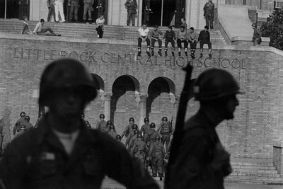

Little Rock, 1957: "The President had no choice but to sustain the court or surrender to anarchy."

1. Do you agree with the caption? Explain.

2. Was sending in federal troops the only way to resolve the situation in Little Rock? Explain.

3. What do you think might have happened had Eisenhower not sent in the troops?
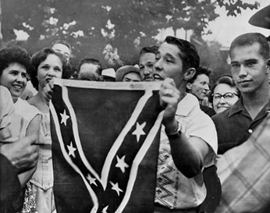
September 4, 1957: In Little Rock, Ark., where the Governor called out national Guard, shouts of approval greeted Paul Davis Taylor as he waved a Confederate flag at Central High School.

4. What do you think the man holding the Confederate flag was trying to accomplish? Why do you think this?

5. How does the crowd appear to be reacting to his action? How do you feel about this?

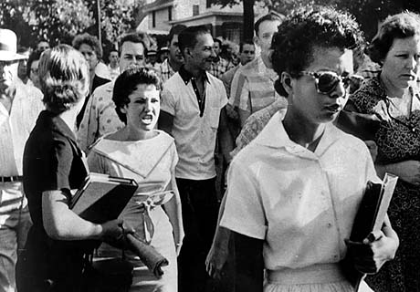
September 5, 1957: A jeering student follows Elizabeth Eckford as she walks down a line of National Guardsmen who barred her from entering Central High School.

6. Why do you think school integration made so many Southerners angry? Was it simple racism, did they feel threatened somehow, or were there other factors at work? Explain your reasoning in a few sentences.

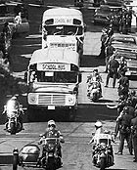
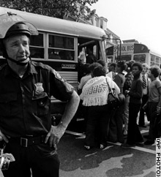
Police in riot gear escort black school children bused into white neighborhoods in Boston, September 1974. During the early days of busing in the city, some black students were pelted with stones and racial abuse.

7. One solution instituted in later years was to bus students from minority communities into white communities. In your opinion, can measures like “forced integration” truly solve problems of racial inequality? Explain your answer in a few sentences.

8. Did the photos and caption above influence your answer? Explain.

